Fontys University of Applied Sciences

Eindhoven, The Netherlands

Design Document

PROCP

AIRPORT LUGGAGE SIMULATION

Team IT Rockstars | 30-October -2020

**Group E**

**Team members:**

Aleksander Sopiqoti

Bilal Delal Aktas

Fadi Abboud

Emad Albouni

Obaid Ghafoori

Ralia Larmonie **Tutor:** Mr. Emin Thaq

Contents

Introduction 2

UML Class Diagram 1

Non-trivial Sequence Diagram(s) 1

Start/Stop 1

Save 2

Load 3

Graphical User Interface 4

Admin Panel 4

Simulation Details 4

Simulation Window 5

# Introduction

The purpose of the Design Document is to provide a description of the design of a system fully enough to allow for software development to proceed with an understanding of what is to be built and how it is expected to be built. The Design Document provides information necessary to provide description of the details for the software and system to be built.

# UML Class Diagram

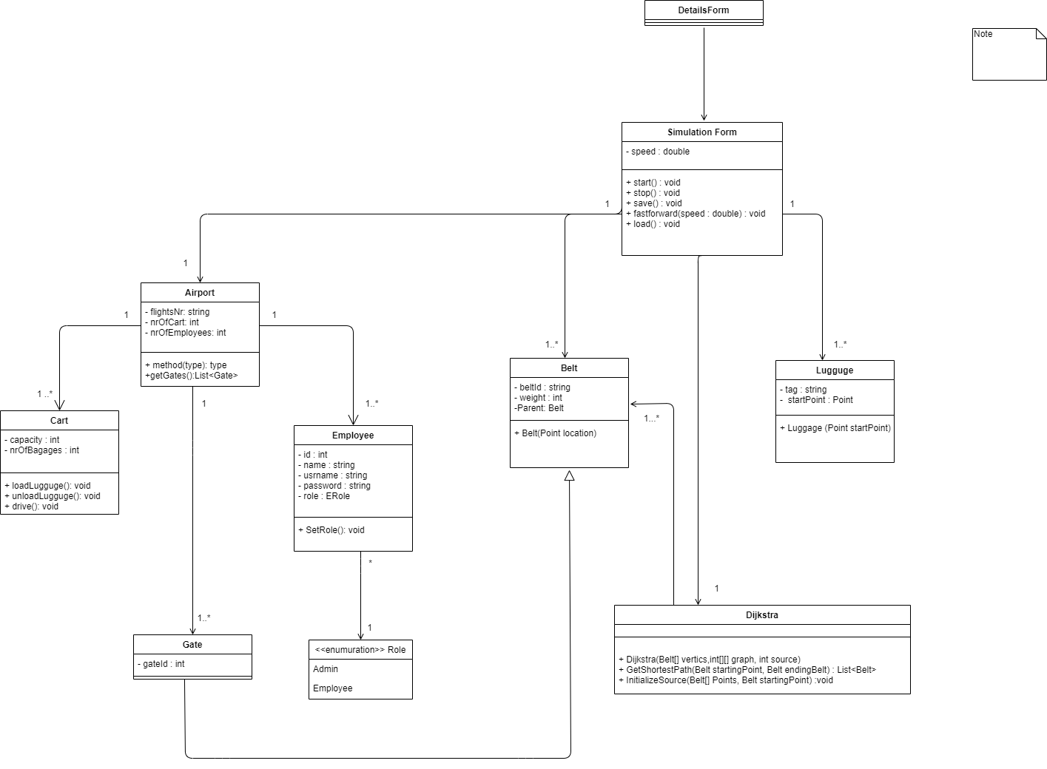

# Non-trivial Sequence Diagram(s)

## Start/Stop

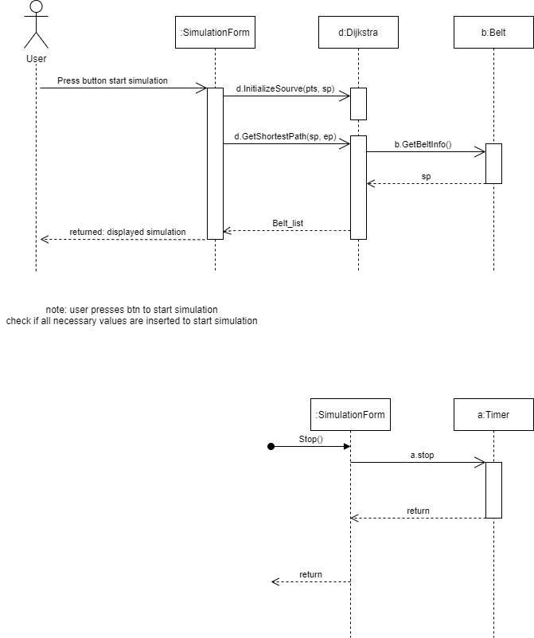

The first sequence diagram illustrates the “start” function, and the second sequence diagram indicates the “stop” function

## Save

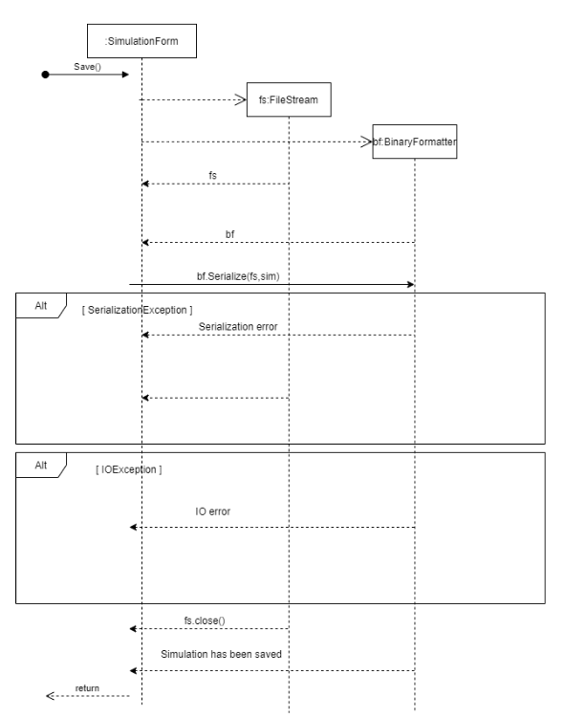

## Load

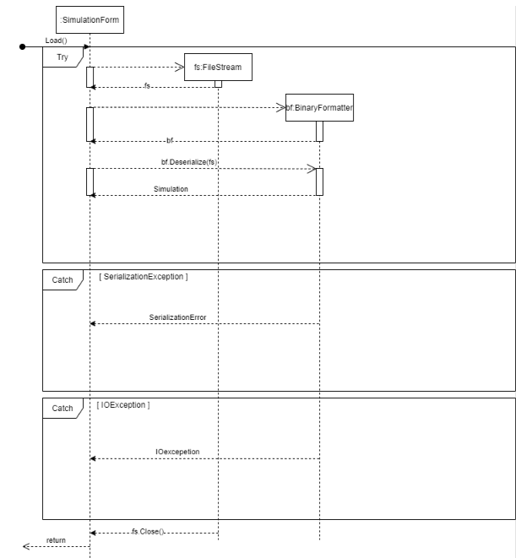

# Graphical User Interface

## Admin Panel

ekran görüntüsü, ekran, iç mekan, bilgisayar içeren bir resim

Açıklama otomatik olarak oluşturuldu

## Simulation Details

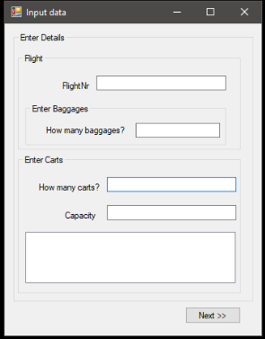

## Simulation Window

metin içeren bir resim

Açıklama otomatik olarak oluşturuldu